INEQUALITY, POVERTY, TAXES, AND TRANSFERS

1. Income Inequality
A. Idea
Even with no market failures, free market outcomes may generate substantial inequality in two dimensions: absolute and relative.
We want to limit inequality. In advanced economies, people pool 30-50% of their income through taxes. Taxes generate an efficiency-equity trade-off

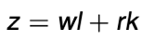
B. Labor vs Capital
Individuals derive market income (before tax) from labor (work) and capital (ownership):
A. Labor income inequality is due to differences in working productivity, effort, institutions (e.g., minimum wage, unions), social norms (e.g., gender norms)
B. Capital income inequality is due to differences in wealth k (due to past saving behavior and inheritances received) and in rates of return r.

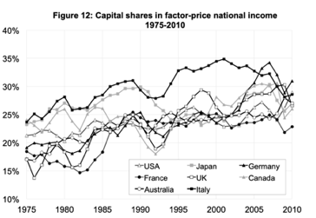
C. Current situation
Capital income rk = 25% of national income z (and increasing), Figure on the right.
Private wealth k ' 500% of national income z (and increasing)
Private wealth has increased while public wealth has declined( Easy money and low political backlash)
Rate of return on wealth = 5/6 %

D. Income vs wealth
Capital income (or wealth) is more concentrated than Labor Income
Wealth is far more concentrated than Income
Wealth: Top 1% has 40%, bottom 50% has basically no wealth (2%)
Income: Top 1% has 20% total national income on a pretax basis (15% of total labor income), bottom 50% has 13%
Income and wealth inequality are pretty similar for the world as a whole.

E. Income in deep (US)
a. Trends
Labor income inequality has increased since the 1970s. Look at how different income growth : Bottom 50% pre-tax income per adult have stagnated since 1980 in spite of a 60% increase in average national income.
!
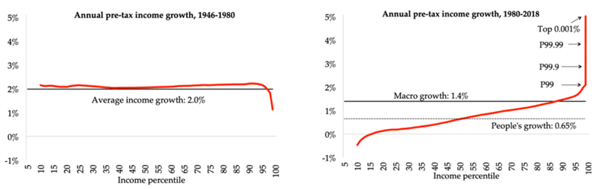
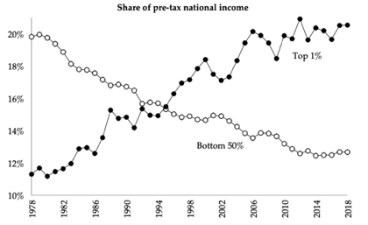

*figure 1: these are relative, not absolute measures. On absolute terms we are clearly on average better off economically today than in the 50s
Top income shares dropped from 1929 to 1950 and increased sharply since 1980.
However, the surge in top income shares has happened primarily in English-speaking countries, not as much in Continental Europe and Japan

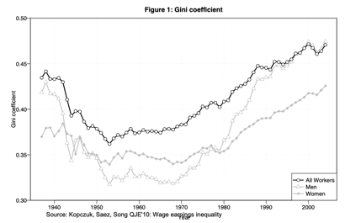
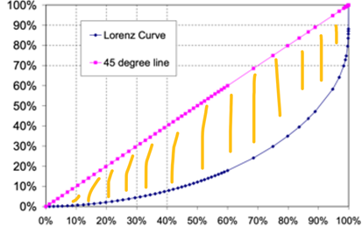
F. GINI
Lorenz curve L(p): x = population, standardized to 1 and ordered by income, y = share of total income --> at percentile p is the fraction of total income earned by individuals below percentile p.
Gini = 2 * Area between 45-degree line and Lorenz curve
Gini=0 means perfect equality.
Gini=1 means complete inequality (i.e., the top person has all the income).

G. Gender gap
We mean the % of global labor income earned by female
The gender gap has decreased but remains substantial at the top of the distribution (figure 1). Female work participation has increased a lot but very few women at in top 0.1% income distribution (Male make 85% of the top 1% of labor income distribution, figure 2)
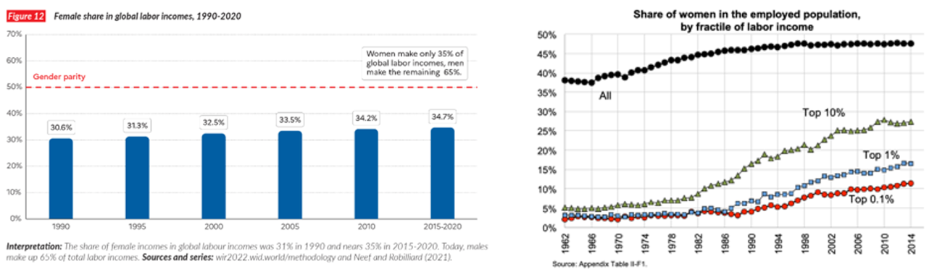

H. Between countries comparison:

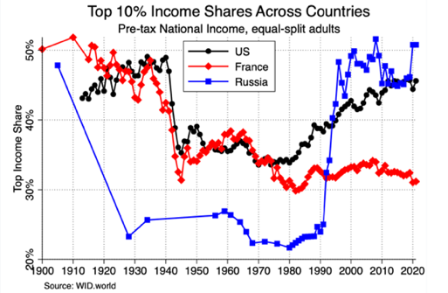

I. Income globally
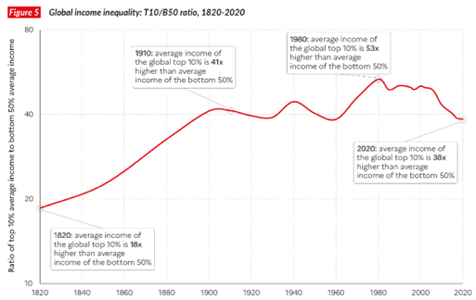

2. Poverty rates
A. Absolute: Fraction of population with disposable income (normalized by family size) below poverty threshold fixed in real terms.
Basic: absolute approach, how many people are starving. This figure has decreased sharply in the last decades (nothing happened in Africa, it’s all about Asia rise) if we consider the world, instead it is flat if we consider US.
Generally speaking, you do not use gross income (pre-tax), but disposable income c = z - T(z) + B(z) + E
where T(z) is tax, B(z) govt transfers, E net private transfers (e.g., charity, family, friends).
Ideally, poverty should be defined at the individual level based on individual consumption. However, many consumption goods are shared within the family, we need to account for the family scale we compute family disposable income and we split by the n of members

US Poverty Line definitions
Based on money income (NOT disposable income)= market income before taxes + government transfers + private transfers.
In 2022: $14K for a single adult, $18K for a family of 2, $23K for a family of 3, $28K for a family of 4.
Poverty thresholds are adjusted annually using the official CPI.
Conceptual weaknesses:
i. Payroll taxes are NOT deducted.
ii. Income tax credits (EITC, Child Tax Credit) are NOT added.
iii. In-kind transfers (Medicaid, food stamps, public housing) do NOT count. But the definition is hard to change (due to political constraints).

B. Relative: Fraction of population with disposable income (normalized by family size) below poverty threshold fixed relative to median (Eu uses 60% of median). Basic: relative approach
C. comparison: Absolute poverty falls in the long run with economic growth (e.g., nobody in the US is World Bank poor), but relative poverty does not. Relative measures do not consider growth effect. Relative inequality may signal Italy has more ‘poor’ than Hungary, but this is due to the distribution of income, not absolute values or living conditions. However, also relative poverty plays a big role + absolute poverty line needs to be set rigorously.
--> Conclusion: Health measures (mortality, stunting) are the most relevant absolute measures of deprivation in the long-run.

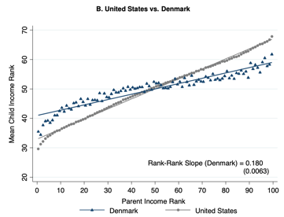
3. Intergenerational Income Mobility
A. Idea
We want children to have equal opportunities --> parent income should not affect their income
Simple measure of linkage between parent-child income: average income rank of children by income rank of parents
The steeper the slope the more the parents’ income predicts your future income
Note: also alpha is very important (opportunity for worst of the worst)

B. Results
a. The US has less mobility than European countries (especially Scandinavian countries such as Denmark).
Moreover, if you check the Probability that a child born to parents in the bottom fifth of the income distribution reaches the top fifth: Usa 7.5%, UK 9%, Denmark 11.7% and Canada 13.5%
b. Substantial heterogeneity in mobility across cities in the US. Characteristics of places with high mobility: low segregation, low-income inequality, good K-12 schools, high social capital, and high family stability (not good 1 single parent to take care of kid, less financial resources).
c. Substantial racial disparity in mobility (Chetty et al. 2020): born from black family less opportunities ()
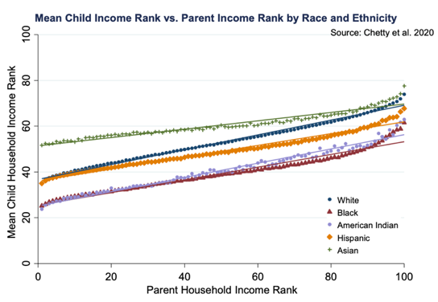

4. Government Redistribution with Taxes and Transfers
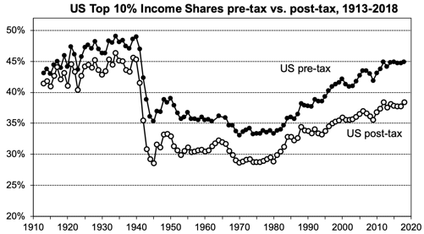
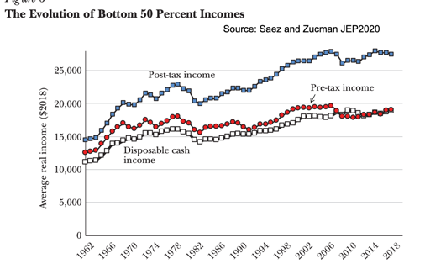
A. Disposable income definition
Gov. provide Transfers and ask taxes:
post-tax (disposable) income: y = z - T(z) + B(z)
--> y = z - T(z) + G (with G = transfers + public good spending)

B. regressive vs progressive transfers
A. If inequality in y is less than inequality in z --> The tax and transfer system is redistributive (or progressive).
﻿﻿﻿﻿B. If inequality in y is more than inequality in z --> The tax and transfer system is regressive.
*Note figure 1. pretax post tax before 1940 is very similar

5. Inequality during Covid
Figure 1: COVID had a large negative impact on factor income (labor + capital income), especially among low earners (because of job losses), but actually all income groups recovered fast (in contrast to the Great Recession of 2008)
Figure 2: Moreover actually disposable income increased a lot during COVID, especially so for bottom 50% due to government transfers (e.g., direct checks to families, extra unemployment benefits for job losers, paycheck protection program for businesses (loans for businesses close to bankruptcy), expanded child tax credit)

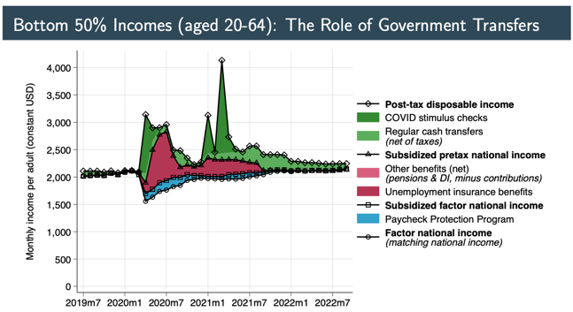
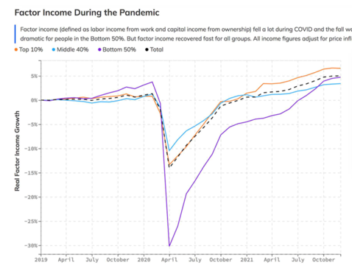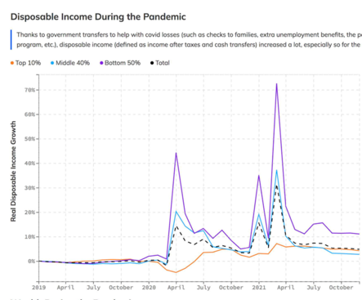

6. US Tax System (2/3 of total taxes)
A. Federal level
a. Individual income tax (on both labor + capital income): is progressive, average tax rate for rich person is higher than for poor
b. Payroll taxes: financing social security programs are regressive (40% of revenue)
Payroll taxes are generally considered regressive. They are levied at a flat rate of 12.4 percent up to a maximum amount of an employee’s wages ($147,000 in calendar year 2022). First, compared with lower-income households, higher-income households receive more of their income from sources other than wages, such as capital gains and dividends, which are not subject to the payroll tax. However, because wages rise as a share of income over the first four quintiles of the distribution, payroll taxes are slightly progressive until high income levels are reached. Second, no cap would be neutral, with cap it is regressive: individuals who earn more than the cap pay a smaller percentage of their total income in Social Security taxes than those who earn less.

c. Corporate income tax: is progressive (15% of revenue).
You are tax rich people + it is progressive wrt profits

d. Estate taxes: are very progressive
The estate tax is only imposed on households with high levels of wealth ($11.4 million). High wealth is almost always commensurate with high income, so, when households are classified by income, virtually the entire estate tax burden falls on the very highest income households.

e. Minor excise taxes(consumption): are very regressive
households that consume more of the taxed good or service as a share of their total consumption face more of the tax burden from this change in relative prices.
Poor tend to spend way more of total income in consumption

B. State + Local Tax level (1/3 of total taxes)
Decentralized governments can experiment, be tailored to local views, create tax competition, and make redistribution harder (recall the Tiebout model).
a. Individual + Corporate income taxes are progressive
b. Sales taxes + Excise taxes (tax on consumption) are very regressive
c. Real estate property taxes (tax on housing wealth) are slightly progressive

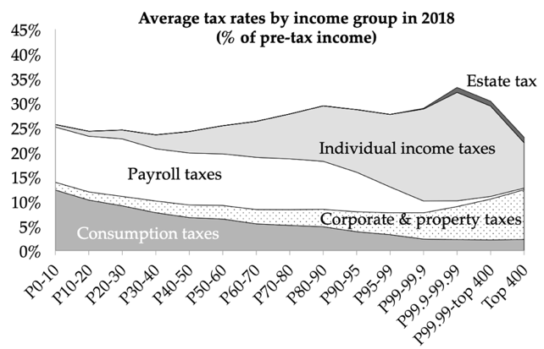
* Figure 1 you can see here what’s progressive and what’s not!!!!!!!!!!!!!

Key points:
I. The US tax and transfer system is progressive overall.
Pre-tax national income is less equally distributed than post-tax/post-transfer national income.
II. Long Term Changes: Before 1913, US taxes were primarily tariffs, excises, and real estate property taxes, minimal welfare state (i.e., small government).
III. Medium Term Changes: The US tax progressivity has declined since 1950 (last figure), but government redistribution through transfers has increased (via Medicaid, Social Security retirement, DI, UI etc).
